EENG 385 - Electronic Devices and Circuits

Lab 7 – Audio amplifier

Lab Handout

# Objective

The objective of this lab is to study the configure, use and analyze, the audio amplifier on the Audio board.

# Audio Amplifier:

The heart of the audio amplifier is shown in the schematic shown in Figure 1.

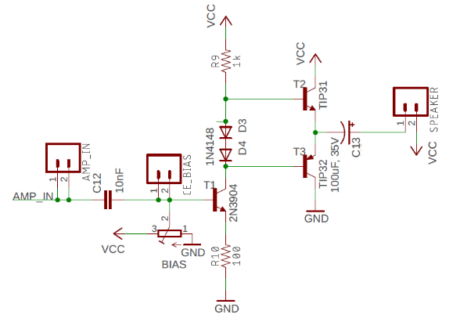

Figure : The core of the audio amplifier consists of a voltage gain stage followed by a current gain stage.

# The output stage consists of a pair transistors T2 and T3 each in the common collector configuration. In the configuration shown in Figure 1:

# The base of T2 is 0.7V above the emitter.

* The base of T3 is 0.7V below the emitter

When an NPN and PNP transistor are arranged as shown in Figure 1, they are said to form a push/pull pair. The term alludes to the manner in which the pair pull the speaker towards VCC or push it towards GND. When we analyze the individual transistors in the push/pull pair we will refer to them as emitter followers. The output of the push/pull pair should be centered at 4.5V so that the output voltage can swing as far as possible before hitting either rail.

**Compute the emitter follower base voltages:**

1. In order for the output of the push/pull pair be 4.5V, what should you set the base voltage of transistor T2 to?

**In order for the output of the push/pull pair be 4.5V, the base of T2 must sit 0.7V above its emitter. This would make the base voltage 4.5V + 0.7V = 5.2V.**

1. In order for the output of the push/pull pair be 4.5V, what should you set the base voltage of transistor T3 to?

**In order for the output of the push/pull pair be 4.5V, the base of T3 must sit 0.7V below its emitter. This would make the base voltage 4.5V - 0.7V = 3.8V.**

1. What is the voltage difference between the voltages found in question 1 and 2?

**The voltage drop is 5.2V – 3.8V = 1.4V.**

1. What is the voltage drop across the pair of diodes D3 and D4?

**The voltage drop across 2 diodes is 2*0.7V = 1.4V.**

# Common Emitter Theory:

Transistor T1 in Figure 2 is configured as a common emitter. The base of T1 is the input and the collector is the output. Both the input and output voltages are measured with respect to the emitter terminal; thus, the emitter is in common with both the base and collector.

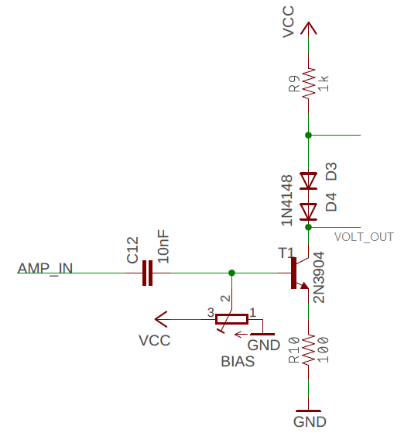

Figure : The common emitter stage of the audio amplifier.

The AMP_IN signal in Figure 2 comes from our audio source (your phone or computer). Capacitor C12 removes the DC component from the audio signal and passes along an AC signal centered at 0V. The audio signal output of the capacitor is added (via superposition) to the bias voltage supplied by the potentiometer. You need to adjust the bias voltage so that the base of the push/pull pair are set to the voltages you calculated in questions 1 and 2 above. In other words, in the absence of an AC signal source, you need to:

* Set the collector of transistor T1 (which is connected to the base of transistor T3) to the voltage you computed in **Compute the emitter follower base voltages** question 2.
* Set the anode of diode D3 in Figure 2 (which is connected to the base of transistor T2) to the you computed in **Compute the emitter follower base voltages** question 1.

Now you will use this information to adjust the bias voltage of the common emitter stage.

**Compute the common emitter bias voltage:**

1. Find IC so that the base of T2 is 5.2V where VCC = 9V.

**IC = (9V – 5.2V)/1kΩ = 3.8mA**

1. Find VE assuming that IE is equal to IC

**VE = 3.3mA * 100 = 380mV**

1. Find VB, your value should be close 1V.

**VB = 0.33V + 0.7V = 1.08V**

Let’s use this information to configure the bias voltage on the audio board. To do this you need a brief introduction to the audio cable and jack.

I hope that this comes as no surprise, but when you put on a pair of headphones to listen to music, your left and right ears hear slightly different audio. This is called stereo sound and is done to produce a more realistic and pleasing sound. The audio board was designed to interface to stereo audio sources, so will have left and right audio signals, called channels.

The left side of Figure 3 shows the structure of the audio cable you will use to connect the audio source from your phone or a computer to the audio board. The audio board connection is made through the audio jack shown at right in Figure 3. The metal tip of the audio cable has 3 electrically isolated rings, each with the purpose shown. When you insert the metal tip into the mating audio jack, see AUDIO_JACK_3.5MM at right in Figure 3, the ground ring connects to ground on the audio board, while the left and right audio channels connect to the 2 pins on the audio jack that have red tracks leaving them. Each audio channel goes to one of the two AUDIO_IN pins. Unless you are dealing with a mono audio source (an audio source with a single channel), it does not matter which audio channel you amplify. In other words, it does not matter which of the AUDIO_IN pins you send to the audio amplifier stage.

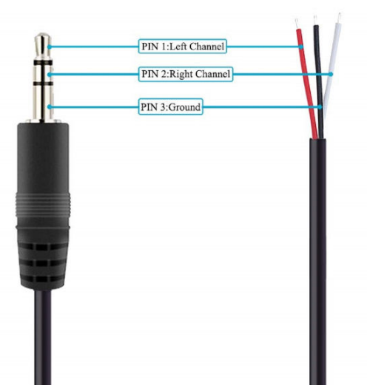 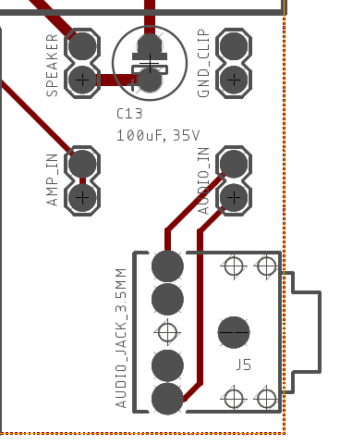

Figure : A 3-pole TRS cable Audio cable and the

Follow these steps to properly configure the inputs of the audio board

* Apply power through the barrel connector or the connectors adjacent to the jack.
* Connect a jumper between the AUDIO_IN and AMP_IN. If you are using a stereo source, it does not matter which AUDIO_IN pin you connect to (see Figure 3). Both AMP_IN pins are tied together, so it does not matter which AMP_IN pin you connect to.
* Connect the speaker to the pair of SPEAKER pins (adjacent to the 100uF electrolytic capacitor).
* Go to the large cabinet in the northwest corner of Brown 304 (the tall one with lots of blue and grey pull drawers). Grab a small screwdriver from the “SMALL SCREWDRIVER” drawer.
* Use a DMM or oscilloscope to measure the voltage on CE_BIAS plated through holes. Since both holes are connected, it does not matter which one you measure from. Make sure to ground reference your measurement to one of the GND connections.
* Properly configured, your setup should look like Figure 4. Only then should you power up your audio board.
* Adjust the CE_BIAS to the value you computed in step 3. This value should be around 1V.

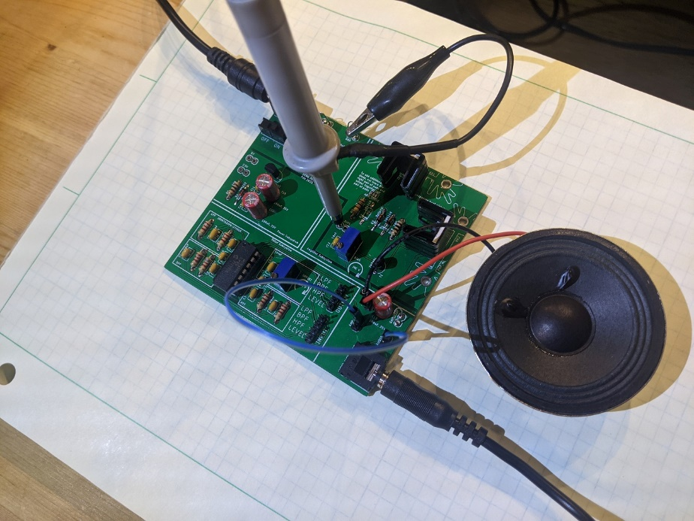

Figure : The audio board connected to a signal source and speaker.

Once you have everything setup as shown in Figure 4, enable the audio output of your signal source and listen the to the output, enjoy.

Now let’s dig into the amplifier using the framework shown in Figure 5. This figure is an abstract version of Figure 1 and describes how the signal is mathematically manipulated. This information is critical in understanding how to improve the quality of the audio output.

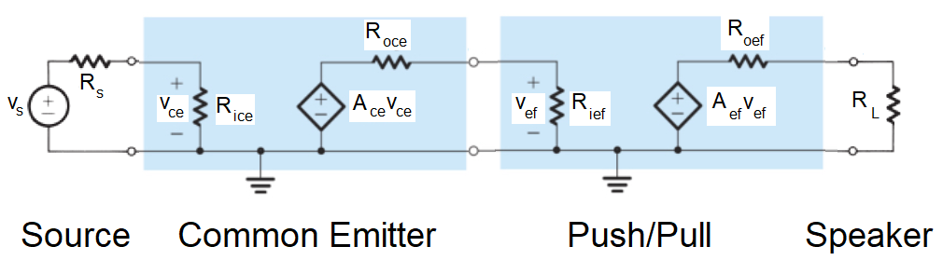

Figure : The audio input to the Audio board goes through a common emitter configuration to amplify the voltage of the signal and then onto a push/pull pair to amplify the current before being sent out to the speakers.

Our task is to put values to the variables in Figure 5 and put them into Table 1. You will do this by a combination of observation and computation.

Table : Model parameters for the cascade amplifier shown in Figure 5.

|  |  |  |  |
| --- | --- | --- | --- |
|  | Rin | Rout | Voltage Gain |
| Source | N/A | Rs = 10Ω | N/A |
| Common Emitter | Rice = β 100Ω | Roce = 1000Ω | Ace = ΔVC / ΔVB = -10 |
| Emitter Follower | Rief = β RL | Roef = RL | Aef = ΔVE / ΔVB = 1 |
| Speaker | RL = 8Ω |  |  |

Let’s start with the attributes of the common emitter amplifier. Please note that this analysis ignores important details that will be added in class. That said, these details do not significantly effect the analysis, in part because of the component values used in the Audio board.

**Compute the input impedance of the common emitter stage - Rice.** You will need to reference Figure 2 during this analysis.

1. What is the relationship between ΔVB and ΔVE?

**ΔVB = ΔVE**

1. Use Ohm’s law to describe the relationship between ΔVE and ΔIE.

**ΔVE = ΔIE * 100Ω**

1. Solve the previous equation for ΔIE and replace ΔVE with ΔVB from equation 1.

**ΔIE = ΔVE / 100Ω ΔIE = ΔVB / 100Ω**

1. Write down the relationship between ΔIE and ΔIB? Hint, it’s a bad parameter.

**ΔIE =  βΔIB**

1. Equate equations 3 and 4 using ΔIE.

**ΔVB / 100Ω = βΔIB**

1. Solve equation 5 for ΔVB/ΔIB, this is the input impedance of the common emitter. Insert this value into the Rice cell of Table 1.

**Rice = ΔVB / ΔIB = β 100Ω**

**Compute the output impedance of the common emitter stage - Roce.** You will need to reference Figure 2 during this analysis.

1. Use Ohm’s law to describe the relationship between ΔVC and ΔIC.

**ΔVC = ΔIC * 1000Ω**

1. Solve equation 1 for ΔVC/ΔIC, this is the output impedance of the common emitter. Insert this value into the Roce cell of Table 1.

**Roce = ΔVC / ΔIC = 1000Ω**

**Compute the gain of the common emitter stage - Ace.** You will need to reference Figure 2 during this analysis.

1. What is the relationship between ΔVB and ΔVE?

**ΔVB = ΔVE**

1. Use Ohm’s law to describe the relationship between ΔVE and ΔIE.

**ΔVE = ΔIE * 100Ω**

1. Solve the previous equation for ΔIE.

**ΔIE = ΔVE / 100Ω**

1. Replace ΔVE in equation 3 for the relationship found in equation 1.

**ΔIE = ΔVB / 100Ω**

1. Use Ohm’s law to describe the relationship between ΔVC and ΔIC. Note the sign!

**ΔVC = -ΔIC * 1000Ω**

1. Since ΔIE = ΔIC, replace ΔIC in the previous equation with ΔIE.

**ΔVC = -ΔIE * 1000Ω**

1. Substitute ΔIE from equation 4 into equation 6.

**ΔVC = -ΔVB * 1000Ω / 100Ω = -ΔVB * 10**

1. Let ΔVC/ΔVB, be the gain. What is the gain of our amplifier? Insert this value into the Ace cell of Table 1.

**Ace = ΔVC / ΔVB = -10**

# Common Emitter Measurements:

Let’s take a break from this analysis and take some measurements from the Audio board. This will allow us to see how they compare to the values you’ve just calculated. We will measure the performance of the common emitter in

To do this configure your oscilloscope as follows. Note, connecting the channel 2 probe to the collector of transistor T1 is tricky and should be performed with the Audio board powered off! You can try to hook the cathode lead of diode D4, trying not to bend the probe hook. Or you can connect directly to the collector of transistor T1 (my preference) while avoiding have the scope hook short out to the adjacent lead of the transistor. Note the collector of T1 is the lead at the bottom of the board - closest to capacitor C13.

|  |  |
| --- | --- |
| Horizontal (scale) | 500us |
| Ch1 probe | CE_BIAS (base of transistor) |
| Ch1 (scale) | 200mV/div |
| Ch1 (coupling) | DC |
| Ch2 probe | Cathode of diode D4 or  Collector of transistor T1 |
| Ch2 (scale) | 1V/div |
| Ch2 (coupling) | AC |
| Trigger source | 1 |
| Trigger slope | ↑ |
| Trigger level | 0V |

Feed the audio input with a 1000Hz tone. My favorite is from the YouTube video The Ultimate Test Tone -Ten hours of 1000 Hz Sine Wave. Turn up the video and PC volume to their maximum, do not connect the speaker for the first 3 questions.

1. Screen shot your input and output waveforms. Center the input on the lower half of the oscilloscope display and center the output in the upper half. Use the Acquire function to smooth out the waveforms. Consider using the measurement tool.

**Shown in Figure 6.**

1. From your oscilloscope trace, how many degree out of phase is the output (collector) with respect to the input (base)?

**The output is exactly 180° out of phase from the input.**

1. Using the data on the oscilloscope, record the amplitude of the input and output waveforms. Form the ratio of the output over the input to determine the gain of the common emitter. Make sure to include the phase difference (negative sign). Note, you will need to know the input and output amplitudes in a later step.

**From the data captured on the oscilloscope, ΔVE / ΔVB = 1140mV/129mV = -8.8.**

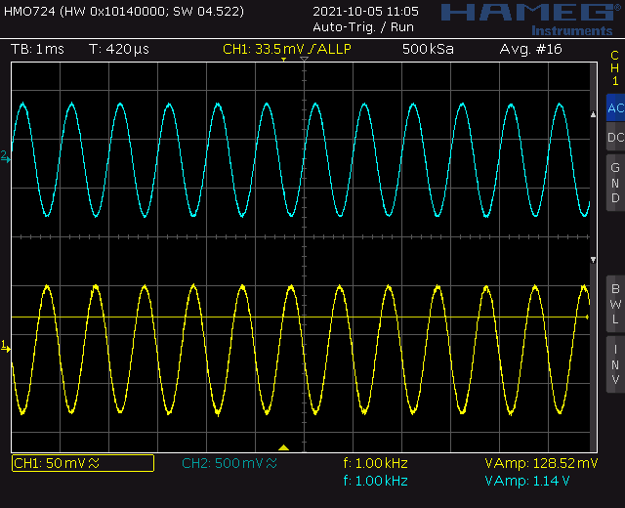

Figure : Oscilloscope capture of an unloaded common emitter input and output - no speaker attached.

Now connect the speaker to the Audio board and make the following measurements. For reasons that will be made clear later, do not alter the amplitude of the input waveform. In other words, do not adjust the sound level.

1. Screen shot your input and output waveforms. Center the input on the lower half of the oscilloscope display and center the output in the upper half. Use the Acquire function to smooth out the waveforms and get better measurements.

**Shown in Figure 7.**

1. From your oscilloscope trace, how many degree out of phase is the output (collector) with respect to the input (base)?

**The output is exactly 180° out of phase from the input.**

1. Using the data on the oscilloscope, record the amplitude of the input and output waveforms. Form the ratio of the output over the input to determine the gain of the common emitter. Make sure to include the phase difference (negative sign). Note, you will need to know the input and output amplitudes in a later step.

**From the data captured on the oscilloscope, ΔVE / ΔVB = 516mV/129mV = -4.**

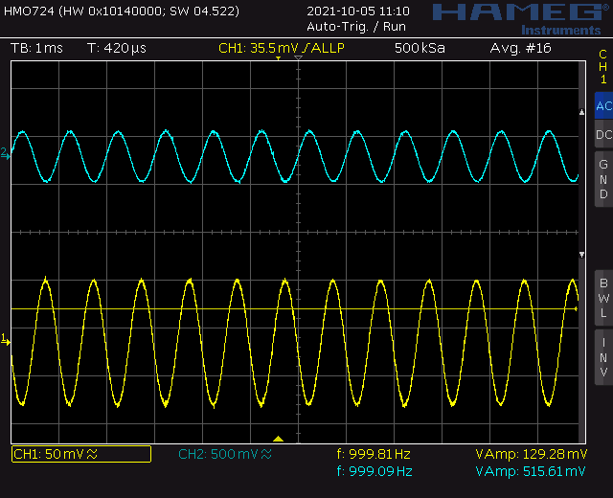

Figure : Oscilloscope capture of a loaded common emitter input and output – 8Ω speaker attached.

You will notice that the gain is reduced by about ½ when the speaker was attached. This should come as a surprise since the speaker is not directly attached to the common emitter stage. So how could the presence of the speaker possibly effect the common emitter stage?

To understand this interaction, you need to look at Figure 5. To start, note that the output voltage from the common emitter Vef in Figure 5 is the collector voltage that you measured with the oscilloscope. In Figure 5 this voltage is formed from the dependent voltage source Ace vce being divided between Roce and Rief. In the next section, you will find that the presence of the speaker (modeled as RL) effects the value in Rief.

# Emitter Follower Theory:

We now return our attention to the cascade amplifier of Figure 5 and fill in the Table 1. We will focus on the push/pull output stage formed by a pair of emitter followers. I’ve made some changes to the push/pull circuit shown in Figure 1 to produce the circuit shown in Figure 8.

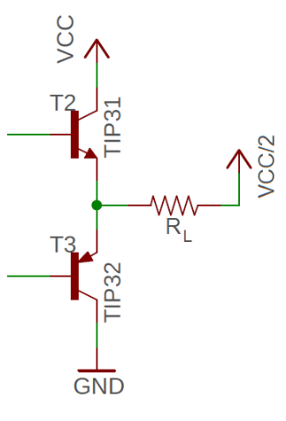

Figure : The push/pull output stage of the audio amplifier consists of a pair of emitter followers.

I made the changes going from Figure 1 to Figure 8. These changes are valid and made to simplify the analysis process. For example, since this is a small signal analysis (we are looking at changes in values e.g. ΔVB) we will ignore the 100uF capacitor C13 in Figure 8 because the capacitor appears as a short at audio-frequencies. The speaker is rated as an 8Ω load, represented by RL – please use RL in the subsequent analysis. Finally, focus on the NPN transistor, T2, in Figure 8 when answering the following questions.

**Compute the input impedance of the emitter follower - Rief.** You will need to reference Figure 8 during this analysis.

1. What is the relationship between ΔVB and ΔVE?

**ΔVB = ΔVE**

1. Use Ohm’s law to describe the relationship between ΔVE and ΔIE. Call the resistance of the speaker RL.

**ΔVE = ΔIE \*** **RL**

1. Solve the previous equation for ΔIE and replace ΔVE with ΔVB (using the relationship in equation 1)

**ΔIE = ΔVE / RL ΔIE = ΔVB / RL**

1. What is the relationship between ΔIE and ΔIB? Hint, it involves a bad parameter.

**ΔIE =  βΔIB**

1. Equate equations 3 and 4 using ΔIE.

**ΔVB / RL = βΔIB**

1. Solve equation 5 for ΔVB/ΔIB, this is the input impedance of the emitter follower. Insert this value into the Rief cell of Table 1.

**Rief = ΔVB / ΔIB = β RL**

**Compute the output impedance of the emitter follower – Roef.** You will need to reference Figure 8 during this analysis.

1. Use Ohm’s law to describe the relationship between ΔVC and ΔIC. Call the resistance of the speaker RL.

**ΔVC = ΔIC * RL**

1. Solve equation 1 for ΔVC/ΔIC, this is the output impedance of the emitter follower. Insert this value into the Roef cell of Table 1.

**Roef = ΔVC / ΔIC = RL**

**Compute the voltage gain of the emitter follower - Aef.** You will need to reference Figure 8 during this analysis.

1. What is the relationship between ΔVB and ΔVE?

**ΔVB = ΔVE**

1. Solve equation 1 for ΔVE/ΔVB, this is the voltage gain of the emitter follower. Insert this value into the Aef cell of Table 1.

**Aef = ΔVE / ΔVB = 1**

# Emitter Follower Measurements:

Let’s return to a question we posed earlier, how can the presence or absence of the speaker effect the output of the common emitter amplifier stage? You now have all the data to answer this question.

1. Use the information from Table 1 in Common Emitter Theory to assign values to:

Rief = β RL

Roce = 1000

1. Use the information in the Common Emitter Measurements section to assign values to:

Vce = 129mV Vef = 1140mV No speaker RL = ∞Ω.

Vce = 129mV Vef = 516mV Speaker RL = 8Ω.

1. Write an equation for Vef in terms of AceVce , Rief and Roce using voltage divider.

Vef = AceVce * (Rief/Rief + Roce)

1. Substitute the values for AceVce , Rief and Roce you found in steps 1 and 2 into the equation 3.

Vef = -10(129mV) * (β RL / β RL + 1000)

1. Determine vef with no speaker attached, let RL = ∞Ω. Let β = 100.

Vef = -10(129mV) * (β RL / β RL + 1000) = 1290mV

1. Determine vef with a speaker attached, let RL = 8Ω.

Vef = -10(129mV) * (β RL / β RL + 1000) = 1290*(800/1800) = 573mV

1. Repeat the calculation in step 6 but substituting the value of AceVce  with the value of Vef you measured with no speaker attached. This is reasonable, because when you measured Vef the load resistor was the oscilloscope which has a very high impedance when compared to Roce.

Vef = -1140mV * (β RL / β RL + 1000) = 1140*(800/1800) = 507mV

# Turn in:

Make a record of your response to numbered items below and turn them in a single copy as your team’s solution on Canvas using the instructions posted there. Include the names of both team members at the top of your solutions. Use complete English sentences to introduce what each of the following listed items (below) is and how it was derived.

**Audio Amplifier**

Steps 1 – 4

**Common Emitter Theory**

Steps 1 – 19

**Common Emitter Measurements**

Steps 1 – 6

**Emitter Follower Theory**

Steps 1 – 10

**Emitter Follower Measurements**

Steps 1 – 7